3.52: a) Setting 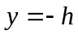 in Eq. (3.27) (h being the stuntwoman’s initial height above the ground) and rearranging gives
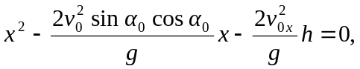
The easier thing to do here is to recognize that this can be put in the form
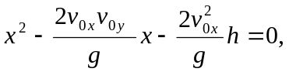
the solution to which is
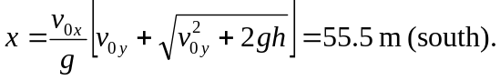
b) The graph of 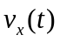 is a horizontal line.
